**PROJECT REPORT**

**ENPM808C**

**PLANNING FOR AUTONOMOUS ROBOTS**

**SAMPLING BASED KINO-DYNAMIC PLANNING  
FOR SELF-DRIVING CARS**

**BY**

**LAKSHMAN KUMAR KUTTUVA NANDHAKUMAR**

**SAMPLING BASED KINO-DYNAMIC PLANNING FOR**

**SELF-DRIVING CARS**

**ABSTRACT**

Robotics has enabled accelerated growth in various industries. One such is the transportation industry. The concept of a Self-driving car was a dream a few decades ago, this has now become reality as a result of technological advancements, particularly in the field of perception and planning. All the major automotive and software companies, like Google, Tesla, Toyota etc. , have now dedicated a significant portion of their work force towards research in Self-Driving Cars. The basic planning problem for a self-driving car would be to drive from an initial point to the desired location, as commanded by the user. A sampling based planner that takes into account the velocity constraints has been proposed here.

**INTRODUCTION**

The main motivation behind the development of self-driving cars is that they can significantly reduce the number of accidents happening on road. Also, the time spent commuting can now be spent for doing other useful things.

Cars can be considered as mobile robots that are non-holonomic in nature. In other words, the dimension of the admissible velocity space is smaller than the dimension of the configuration space. Sampling based planning algorithms are suitable for both holonomic and non-holonomic systems. PRM and RRT are two such algorithms that have been extensively used in solving these problems. These algorithms can be used to find a path to the goal location from an initial location taking into account the velocity constraints of the car. In other words, a trajectory from the source to the destination will be computed by these algorithms.

In order to use these algorithms, the forward kinematics of the car has to be derived. The forward kinematics of the car is computed with respect to its velocity and steering angle. The Ackermann Steering Model has been used to compute the forward kinematics of the car.

**ACKERMANN STEERING MODEL**

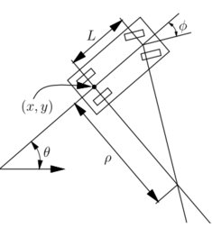

Ackermann steering geometry is a geometric arrangement of linkages in the steering of a car or other vehicle designed to solve the problem of wheels on the inside and outside of a turn needing to trace out circles of different radii.

A simple approximation to perfect Ackermann steering geometry may be generated by moving the steering pivot points inward so as to lie on a line drawn between the steering kingpins and the centre of the rear axle. The steering pivot points are joined by a rigid bar called the tie rod which can also be part of the steering mechanism, in the form of a rack and pinions for instance. With perfect Ackermann, at any angle of steering, the centre point of all of the circles traced by all wheels will lie at a common point. Note that this may be difficult to arrange in practice with simple linkages, and designers are advised to draw or analyze their steering systems over the full range of steering angles.

Modern cars do not use *pure* Ackermann steering, partly because it ignores important dynamic and compliant effects, but the principle is sound for low-speed manoeuvres. Some race cars use reverse Ackermann geometry to compensate for the large difference in slip angle between the inner and outer front tyres while cornering at high speed. The use of such geometry helps reduce tyre temperatures during high-speed cornering but compromises performance in low-speed manoeuvres.

The equations for the simplified Ackermann Steering Model are given below.

Where is the horizontal velocity component of the car

is the vertical velocity component of the car

is the rotational velocity component of the car

is the forward speed of the car with respect to **,**

is the steering angle of the car which is the angle between the line along the axis of the rear wheel joining the common point of rotation and the line connecting the common point of rotation & the centre of the axis along the front wheels.

is the distance between the axis along the rear wheels and the axis along the front wheels

The position of the car can be obtained by integrating the equations above.

In this project ,

has been restricted to two values. It can either be -1 or +1.

has been restricted between two limits.  **[ - , ]**

The configuration space for the model remains 3 dimensional, C =

The control action set which includes Velocity and Steering Angle will be 2 dimensional, U =

**RELATED WORKS**

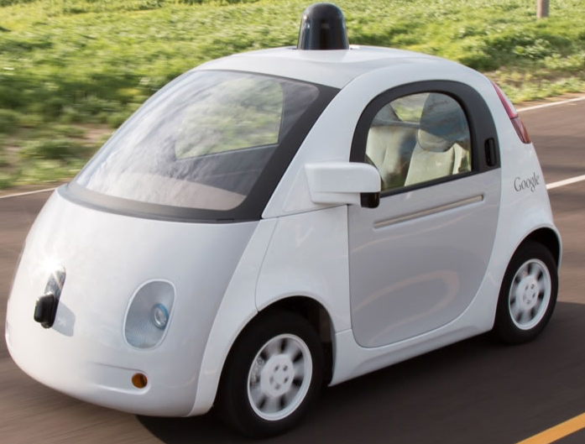

**Google** was among the first ones to start extensive research on Self Driving Cars. They have been using sophisticated perception systems to aid their planning algorithms. They have been using Rapidly exploring Random Trees (RRT) in conjunction with Reinforced Learning to solve the planning problem for Self-Driving Cars.

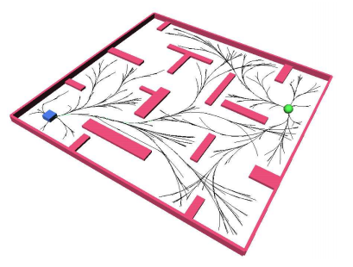

Steven.M.LaValle and James.J.Kuffner Jr, in their paper, ”Randomized Kino-Dynamic Planning” , which was published in the International Journal of Robotics Research 2001, proposed a way to adapt RRT to perform trajectory planning and listed various suggestions on how to improve it. The algorithm proposed in this paper has been implemented and modified a little bit.

**APPROACHES**

**Kino-Dynamic RRT**

**Pseudo Code**

* Tree With
* For Iterations do
* Get From
* Get from
* Get [, ] from
  + ,
* - <
* ()

**Explanation**

The basic difference between the regular RRT and the Kino-Dynamic RRT is that when you select the new configuration to be added to the tree based on the random configuration, in addition to it being collision free , it should also satisfy the Ackermann steering model. Also instead of the Step Size parameter, Step Time parameter is used.

The tree is first initialized with the starting configuration. Then for N number of iterations we will keep adding nodes to the tree unless and otherwise it reaches the goal configuration before that.

The process starts by first generating a random configuration. The random configuration here is generated such that it is biased towards the goal region, so that there is more chance that the tree rapidly expands towards the goal. Here it can be seen that instead of the exact goal point , the region surrounding the goal is biased since when the obstacle space around the goal is huge, exact path to the goal will be very difficult to find and so the tree will expand very slowly.

For this project, the algorithm has been designed such that , every once in 4 times the random node generated will be the goal node and every once in 7 times the random node generated will be in the region surrounding the goal. The radius of the goal region is 50 with the goal point as the center.

After getting the Goal Region Biased Random Configuration, we will find the nearest neighbour to it in the tree.

Now that we have the random and neighbouring configuration, we will have to generate a new configuration based on the Ackermann Steering Model. In order to do this, we will randomly assign the velocity to be either 1 or -1 and the steering angle to be somewhere between -45 and 45 . Based on the velocity and the steering angle, we will simulate a trajectory for a step time . This process of simulating a trajectory is done for ‘M’ number of trials. For every trial the trajectory which has a point that is closest to the random configuration generated is tracked. After the ‘M’ Number of trials, the optimal trajectory with the closest point to the random configuration is selected and checked for collision. If its collision free, the point in the trajectory that is closest to the random configuration will be added as a new configuration to the tree and the corresponding velocity and steering angle to reach this new configuration from the neighbouring node is stored. If its not collision free, the entire new configuration generation process is repeated until a collision free new configuration is obtained.

Once the new configuration is added to the tree , it is checked to see if it approximately matches the goal point. If it does, then the algorithm returns the path to this new configuration. If it does not, the entire process is repeated for ‘N’ number of iterations.

After the algorithm reaches ‘N’ number of iterations, it returns the path nearest to the goal.

Here, on each iteration, only one configuration is added to the tree.

**Kino-Dynamic PRM**

**Pseudo Code**

* Graph With
* For Iterations do
* Get From
* Get from
* For all
  + Get [, ] from
    - ,

**Explanation**

The basic difference between the Kino-Dynamic RRT and the Kino-Dynamic PRM is that you select ‘K’ Nearest Neighbours to the generated random configuration, instead of just one. So for every iteration at most ‘K’ New Configurations will be added. Also instead of a tree structure, this will have a Graph structure.

The graph is first initialized with the starting configuration. Then for N number of iterations we will keep adding nodes to the graph.

The process starts by first generating a random configuration. The random configuration here is generated such that it is biased towards the goal region, so that there is more chance that the tree rapidly expands towards the goal. Here it can be seen that instead of the exact goal point , the region surrounding the goal is biased since when the obstacle space around the goal is huge, exact path to the goal will be very difficult to find and so the tree will expand very slowly.

For this project, the algorithm has been designed such that , every once in 4 times the random node generated will be the goal node and every once in 7 times the random node generated will be in the region surrounding the goal. The radius of the goal region is 50 with the goal point as the center.

After getting the Goal Region Biased Random Configuration, we will find ‘K’ nearest neighbour to it in the tree.

Now that we have the random and neighbouring configurations, we will have to generate a new configuration based on the Ackermann Steering Model. In order to do this, we will randomly assign the velocity to be either 1 or -1 and the steering angle to be somewhere between -45 and 45 . Based on the velocity and the steering angle, we will simulate a trajectory for a step time . This process of simulating a trajectory is done for ‘M’ number of trials. For every trial the trajectory which has a point that is closest to the random configuration generated is tracked. After the ‘M’ Number of trials, the optimal trajectory with the closest point to the random configuration is selected and checked for collision. If its collision free, the point in the trajectory that is closest to the random configuration will be added as a new configuration to the tree and the corresponding velocity and steering angle to reach this new configuration from the neighbouring node is stored. If its not collision free, the entire new configuration generation process is repeated until a collision free new configuration is obtained. This is again repeated for all ‘K’ nearest neighbours.

The entire process goes on for ‘N’ number of iterations. After the algorithm reaches ‘N’ number of iterations, A Star graph search algorithm is implemented to find a path from the starting configuration to the configuration nearest to the goal configuration. The path returned by the A Star algorithm will be the shortest path to the goal configuration among the available paths.

Here, on each iteration, at most K configurations are added to the graph.

**DESIGN OF EXPERIMENTS**

**Input**

The input to the algorithm will be the Starting Configuration , the Goal Configuration and the Map containing the position, size and shape of various obstacles. In the algorithms, it has been assumed that perception of the environment by the car is perfect and the also the car knows where it is exactly located in the map. In other words, here the planning is done under certainty.

**Output**

The output of the algorithm will be the trajectory from the Starting Configuration to the Goal Configuration based on Ackermann Steering Model

**Experiments**

A lot of experiments can be done to check and improve the performance of the algorithms. Some of them are listed below.

* Variation of number of obstacles in the map
* Variation of the shape of obstacles
* Variation of the size of the obstacles
* Variation of the starting and goal configurations
* Variation of algorithm parameters like Step Time, Goal Region Radius, Number of Neighbors to be selected, Number of Iterations to be performed, and so on.

**MATLAB SIMULATION RESULTS**

**Kino-Dynamic RRT**

Picking the Starting Configuration

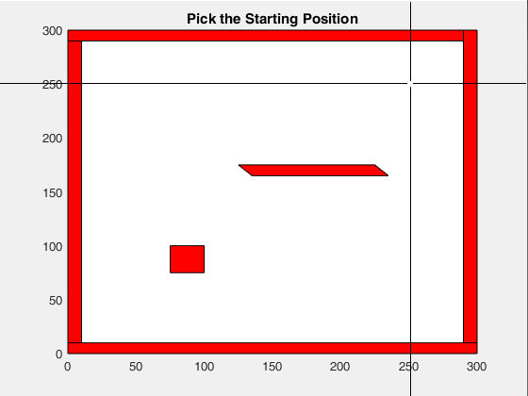

Picking the Goal Configuration

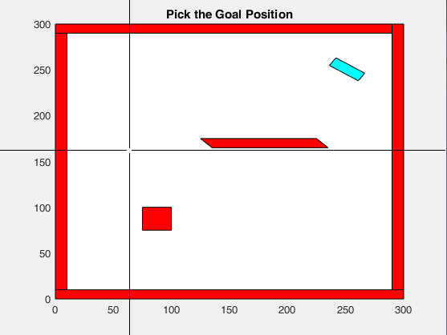

Building the Tree

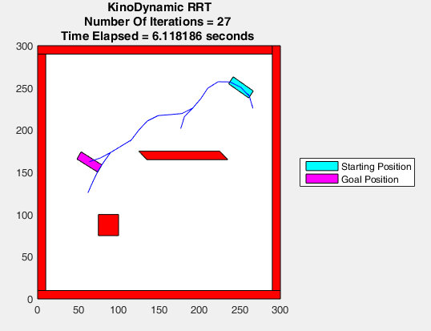

Trajectory to the Goal Configuration

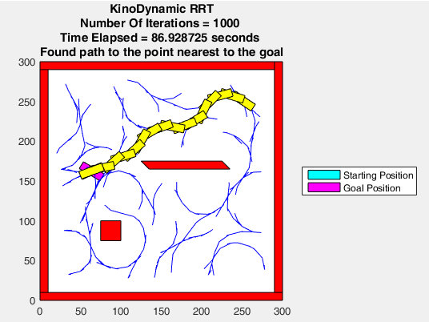

**Special Case**

Initial and goal configuration are at the same position, but different orientation.

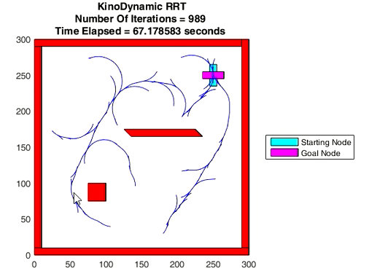

Final position of the car after trajectory is generated by RRT

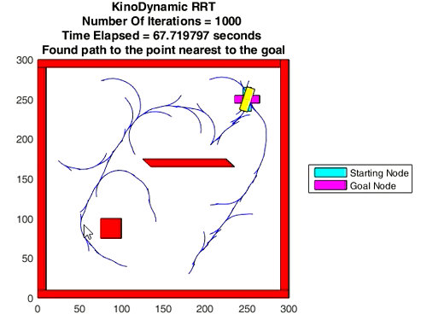

**Kino-Dynamic PRM**

Initial and Goal Configurations

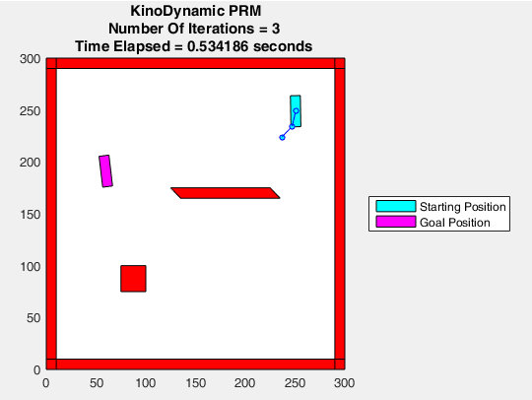

Graph generated by PRM

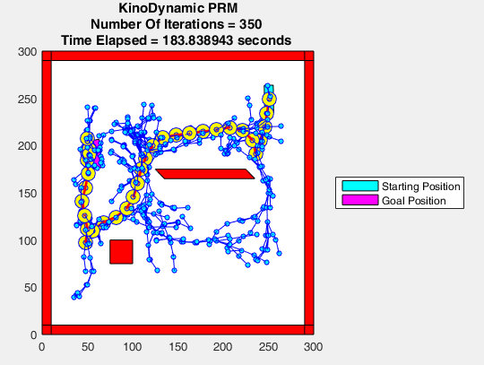

Trajectory from starting configuration to goal configuration generated by PRM

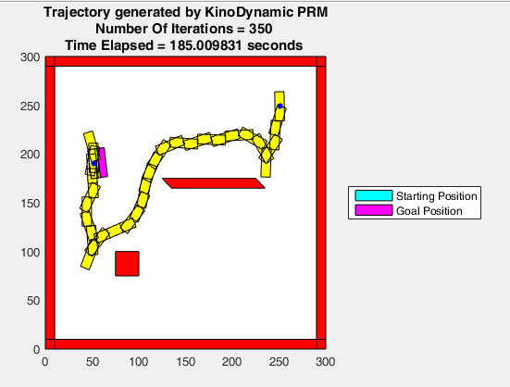

**Special Case**

Initial and goal configuration are at the same position, but different orientation.

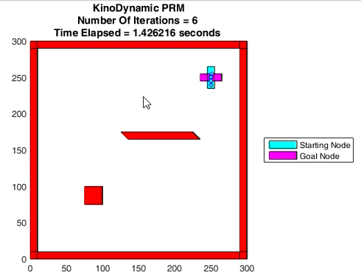

Graph built by the PRM

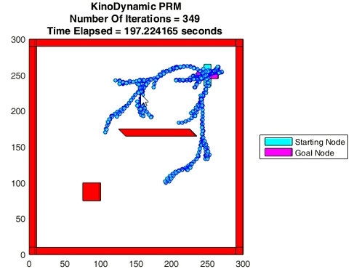

Final position of the car after trajectory is generated by PRM

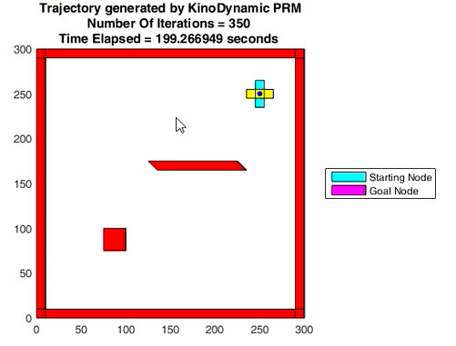

**Kino-Dynamic RRT vs Kino-Dynamic PRM**

As seen from the results, Kino-Dynamic RRT and Kino-Dynamic PRM have their own advantages and disadvantages.

Kino-Dynamic RRT was faster in finding an approximate solution. However the solution is not better than what was generated by PRM. Also, when the initial configuration was very close to the goal configuration, the trajectory generated by RRT did not even reach the half way point to the goal.

On the other hand, Kino-Dynamic PRM was slower than RRT. However they provided way better solutions that RRT and also when the initial configuration is close to the goal configuration, the trajectory generated by PRM reached the exact goal configuration with ease.

Also , Kino-Dynamic PRM provides alternate trajectories to the same point , which can be made use of when there are dynamic obstacles.

Hence it can be said that when the initial configuration and goal configuration are further apart , Kino-Dynamic RRT can be used. When the car gets very close to the goal configuration , Kino-Dynamic PRM can be used.

**FUTURE WORKS**

The algorithms proposed here do not provide an optimal solution. Hence the algorithms proposed here can be upgraded to Kino-Dynamic RRT* and Kino-Dynamic PRM*, which give optimal solutions. Also, the algorithms can be modified to accommodate Dynamic Obstacles and uncertainty of its location in the map.

**REFERENCES**

[1] Steven.M.LaValle and James.J.Kuffner Jr, “Randomized Kino-Dynamic Planning” , International Journal of Robotics Research 2001

[2] Steven M LaValle , “Planning Algorithms”, Cambridge University Press 2005

[3] Google, “Self-Driving Car” , <https://www.google.com/selfdrivingcar/>

[4] Jarrod.M.Snider,”Automatic Steering Methods for Autonomous Automobile Path Tracking”,

Carnegie Mellon University

[5] Garrote et Al, “An RRT-based Navigation Approach for Mobile Robots and Automated Vehicles” , University of Coimbra, Portugal

[6] Jun Qu, “Nonholonomic Mobile Robot Motion Planning”, Motion Strategy Project,

http://msl.cs.uiuc.edu/~lavalle/cs576_1999/projects/junqu/

[7] Peter Corke, “Robotics, Vision and Control”, Springer 2011

[8] Peter Corke, “MATLAB toolboxes: robotics and vision for students and teachers”, IEEE

Robotics and Automation Magazine, Volume 14(4), December 2007

[9] Bruno Siciliano et al.” Robotics Modelling, Planning and Control”, Springer 2009.

[10] Peter Corke ,” A Robotics Toolbox for MATLAB”, IEEE Robotics and Automation Magazine,

Volume 3(1), March 1996

**APPENDIX**

**MATLAB CODE**

**Kino-Dynamic RRT**

function KinoDynamicRRT

clc;

figure;

pause(0);

ShowMap;

RobotLocationXInit = 250;

RobotLocationYInit = 250;

RobotOrientationInit = 0;

RobotLocationXGoal = 50;

RobotLocationYGoal = 50;

RobotOrientationGoal = 90;

MaxNumberOfIterations = 1000;

MaxXYThreshold = 5;

MaxOrientationThreshold = 15;

MaxStepSize = 300;

MinimumX = 0; MaximumX = 300;

MinimumY = 0; MaximumY = 300;

MinimumOrientation = 0 ; MaximumOrientation = 360;

Velocity = 1;

SteeringAngleMax = 45;

NumberOfTrials = 20;

SimulationTime = 15;

SamplingInterval = 0.1;

CarLength = 20;

GoalBiasRegionStepSize = 50;

Alternator = 0;

title('Pick the Starting Position')

while true;

[RobotLocationXInit,RobotLocationYInit] =ginput(1);

RobotOrientationInit = round((MaximumOrientation-MinimumOrientation)*rand + MinimumOrientation );

if ( IsThereAnObstacle(RobotLocationXInit,RobotLocationYInit) == 0 && CheckCollisionDetectionCorners(RobotLocationXInit,RobotLocationYInit,RobotOrientationInit) == 0 && CheckCollisionDetection(RobotLocationXInit,RobotLocationYInit,RobotOrientationInit) == 0 )

break ;

else

title({'The selected starting position is not a valid configuration.' ; ' Select the starting position again'})

end

end

RobotLocationX = RobotLocationXInit;

RobotLocationY = RobotLocationYInit;

RobotOrientation = RobotOrientationInit;

H1 = DrawRobot(RobotLocationX,RobotLocationY,RobotOrientation,'cyan');

pause(0);

hold on;

title('Pick the Goal Position')

while true;

[RobotLocationXGoal,RobotLocationYGoal] =ginput(1);

RobotOrientationGoal = round((MaximumOrientation-MinimumOrientation)*rand + MinimumOrientation );

if ( IsThereAnObstacle(RobotLocationXGoal,RobotLocationYGoal) == 0 && CheckCollisionDetectionCorners(RobotLocationXGoal,RobotLocationYGoal,RobotOrientationGoal) == 0 && CheckCollisionDetection(RobotLocationXGoal,RobotLocationYGoal,RobotOrientationGoal) == 0 )

break ;

else

title({'The selected goal position is not a valid configuration';' Select the goal position again'});

end

end

title('KinoDynamic RRT')

H2 = DrawRobot(RobotLocationXGoal,RobotLocationYGoal,RobotOrientationGoal,'magenta');

pause(0);

legend([H1 H2],{'Starting Position','Goal Position'},'Location','eastoutside');

tree.vertex(1).x = RobotLocationXInit;

tree.vertex(1).y = RobotLocationYInit;

tree.vertex(1).o = RobotOrientationInit;

tree.vertex(1).PreviousX = RobotLocationXInit;

tree.vertex(1).PreviousY = RobotLocationYInit;

tree.vertex(1).PreviousOrientation = RobotOrientationInit;

tree.vertex(1).Distance=0;

tree.vertex(1).ind = 1; tree.vertex(1).indPrev = 0;

tic;

for iter = 2:MaxNumberOfIterations

str = sprintf('Number Of Iterations = %d ',iter);

TimeElapsed = sprintf('Time Elapsed = %f seconds ',toc);

title({'KinoDynamic RRT';str;TimeElapsed});

while true

while true

Alternator = Alternator + 1;

if mod(Alternator,7) == 0

RX = (RobotLocationXGoal - (GoalBiasRegionStepSize/2));

RandX = (GoalBiasRegionStepSize)*rand;

if RX < MinimumX

RX = MinimumX ;

else

if RX > (MaximumX - GoalBiasRegionStepSize)

RX = MaximumX - GoalBiasRegionStepSize;

end

end

RandomVariableX = round( RandX + RX );

if RandomVariableX < MinimumX

RandomVariableX = MinimumX;

else

if RandomVariableX > MaximumX

RandomVariableX = MaximumX;

end

end

RY = (RobotLocationYGoal - (GoalBiasRegionStepSize/2));

RandY = (GoalBiasRegionStepSize)*rand;

if RY < MinimumY

RY = MinimumY ;

else

if RY > (MaximumY - GoalBiasRegionStepSize)

RY = MaximumY - GoalBiasRegionStepSize;

end

end

RandomVariableY = round( RandY + RY );

if RandomVariableY < MinimumY

RandomVariableY = MinimumY;

else

if RandomVariableY > MaximumY

RandomVariableY = MaximumY;

end

end

RO = (RobotOrientationGoal - (GoalBiasRegionStepSize/2));

RandO = (GoalBiasRegionStepSize)*rand;

if RO < MinimumOrientation

RO = MinimumOrientation ;

else

if RO > (MaximumOrientation - GoalBiasRegionStepSize)

RO = MaximumOrientation - GoalBiasRegionStepSize;

end

end

RandomVariableO = round( RandO + RO );

if RandomVariableO < MinimumOrientation

RandomVariableO = MinimumOrientation;

else

if RandomVariableO > MaximumOrientation

RandomVariableO = MaximumOrientation;

end

end

else

if mod(Alternator,4) == 0

RandomVariableX = RobotLocationXGoal ;

RandomVariableY = RobotLocationYGoal ;

RandomVariableO = RobotOrientationGoal;

else

RandomVariableX = round(MaxStepSize*rand);

RandomVariableY = round(MaxStepSize*rand);

RandomVariableO = round((MaximumOrientation-MinimumOrientation)*rand + MinimumOrientation );

end

end

if ( IsThereAnObstacle(RandomVariableX,RandomVariableY) == 0 && CheckCollisionDetectionCorners(RandomVariableX,RandomVariableY,RandomVariableO) == 0 && CheckCollisionDetection(RandomVariableX,RandomVariableY,RandomVariableO) == 0 )

break ;

end

end

Distance = Inf*ones(1,length(tree.vertex));

for j = 1:length(tree.vertex)

Distance(j) = sqrt( (RandomVariableX - tree.vertex(j).x)^2 + (RandomVariableY-tree.vertex(j).y)^2 + (deg2rad(RandomVariableO)-deg2rad(tree.vertex(j).o))^2 );

end

[val, ind] = min(Distance);

NearestNodeX = tree.vertex(ind).x;

NearestNodeY = tree.vertex(ind).y;

NearestNodeOrientation = tree.vertex(ind).o;

FoundAFeasiblePath = 1;

NumberOfTries =0;

while true

[PathPoints,Index,OptimalVelocity,OptimalSteeringAngle] = BestPath(NearestNodeX,NearestNodeY,NearestNodeOrientation,RandomVariableX,RandomVariableY,RandomVariableO);

ObstacleFlag = 0;

for m = 1 : Index

if ( IsThereAnObstacle(PathPoints(m,1),PathPoints(m,2)) == 1 || CheckCollisionDetectionCorners(PathPoints(m,1),PathPoints(m,2),PathPoints(m,3)) == 1 || CheckCollisionDetection(PathPoints(m,1),PathPoints(m,2),PathPoints(m,3)) == 1 )

ObstacleFlag = 1;

break ;

end

end

if ObstacleFlag == 0

break;

end

NumberOfTries = NumberOfTries + 1 ;

if NumberOfTries > 3

FoundAFeasiblePath = 0;

break;

end

end

if FoundAFeasiblePath == 1

break;

end

end

NewX = PathPoints(Index,1);

NewY = PathPoints(Index,2);

NewO = PathPoints(Index,3);

tree.vertex(iter).x = NewX; tree.vertex(iter).y = NewY; tree.vertex(iter).o = NewO;

tree.vertex(iter).v = OptimalVelocity; tree.vertex(iter).s = OptimalSteeringAngle;

tree.vertex(iter).PreviousX = tree.vertex(ind).x;

tree.vertex(iter).PreviousY = tree.vertex(ind).y;

tree.vertex(iter).PreviousOrientation = tree.vertex(ind).o;

tree.vertex(iter).ind = iter; tree.vertex(iter).indPrev = ind;

if sqrt( (NewX-RobotLocationXGoal)^2 + (NewY-RobotLocationYGoal)^2 ) <= MaxXYThreshold

if abs(NewO - RobotOrientationGoal) < MaxOrientationThreshold

plot([tree.vertex(iter).x; tree.vertex(ind).x],[tree.vertex(iter).y; tree.vertex(ind).y], 'r');

break;

end

end

plot([tree.vertex(iter).x; tree.vertex(ind).x],[tree.vertex(iter).y; tree.vertex(ind).y], 'b');

pause(0);

end

if iter >= MaxNumberOfIterations

Statement = 'Found path to the point nearest to the goal';

title({'KinoDynamic RRT';str;TimeElapsed;Statement});

else

Statement = 'Found path to the goal';

title({'KinoDynamic RRT';str;TimeElapsed;Statement});

end

Distance = Inf*ones(1,length(tree.vertex));

for j = 1:length(tree.vertex)

Distance(j) = sqrt( (RobotLocationXGoal - tree.vertex(j).x)^2 + (RobotLocationYGoal-tree.vertex(j).y)^2 + (deg2rad(RobotOrientationGoal)-deg2rad(tree.vertex(j).o))^2 );

end

[val, ind] = min(Distance);

NearestNodeX = tree.vertex(ind).x;

NearestNodeY = tree.vertex(ind).y;

NearestNodeOrientation = tree.vertex(ind).o;

path.pos(1).x = NearestNodeX; path.pos(1).y = NearestNodeY; path.pos(1).o = NearestNodeOrientation;

pathIndex = tree.vertex(ind).ind;

j= -1;

PathIndices = [pathIndex];

while true

pathIndex = tree.vertex(pathIndex).indPrev;

PathIndices = union(PathIndices,pathIndex);

if pathIndex == 1

break;

end

end

PI = 1;

while 1

path.pos(j+2).x = tree.vertex(PathIndices(PI)).x;

path.pos(j+2).y = tree.vertex(PathIndices(PI)).y;

path.pos(j+2).o = tree.vertex(PathIndices(PI)).o;

PI = PI + 1;

H3 = DrawRobot(path.pos(j+2).x,path.pos(j+2).y,path.pos(j+2).o,'yellow');

pause(0.2);

if PI == length(PathIndices)+1

break;

else

% delete(H3);

end

j=j+1;

end

for j = 2:length(path.pos)

plot([path.pos(j).x; path.pos(j-1).x;], [path.pos(j).y; path.pos(j-1).y], 'r', 'Linewidth', 3);

end

function H = DrawRobot(RobotLocation_X,RobotLocation_Y,Robot_Orientation,Color)

RobotLocationXCorner1 = RobotLocation_X + (-15*cosd(Robot_Orientation)) - ( 5*sind(Robot_Orientation)) ;

RobotLocationYCorner1 = RobotLocation_Y + (-15*sind(Robot_Orientation)) + ( 5*cosd(Robot_Orientation)) ;

RobotLocationXCorner2 = RobotLocation_X + (15*cosd(Robot_Orientation)) - ( 5*sind(Robot_Orientation)) ;

RobotLocationYCorner2 = RobotLocation_Y + (15*sind(Robot_Orientation)) + ( 5*cosd(Robot_Orientation)) ;

RobotLocationXCorner3 = RobotLocation_X + (15*cosd(Robot_Orientation)) - ( -5*sind(Robot_Orientation)) ;

RobotLocationYCorner3 = RobotLocation_Y + (15*sind(Robot_Orientation)) + ( -5*cosd(Robot_Orientation)) ;

RobotLocationXCorner4 = RobotLocation_X + (-15*cosd(Robot_Orientation)) - ( -5*sind(Robot_Orientation)) ;

RobotLocationYCorner4 = RobotLocation_Y + (-15*sind(Robot_Orientation)) + ( -5*cosd(Robot_Orientation)) ;

RobotXVertices = [RobotLocationXCorner1 RobotLocationXCorner2 RobotLocationXCorner3 RobotLocationXCorner4 ];

RobotYVertices = [RobotLocationYCorner1 RobotLocationYCorner2 RobotLocationYCorner3 RobotLocationYCorner4 ];

H = patch(RobotXVertices,RobotYVertices,Color);

end

function [PathPoints,Index,OptimalVelocity,OptimalSteeringAngle] = BestPath(NearestNodeX,NearestNodeY,NearestNodeOrientation,RandomVariableX,RandomVariableY,RandomVariableO)

DistanceThreshold = Inf;

for i = 1 : NumberOfTrials

if rand >= 0.5

Speed = Velocity;

else

Speed = -Velocity;

end

SteeringAngle = (2*rand - 1)* SteeringAngleMax;

TempX = NearestNodeX;

TempY = NearestNodeY;

TempO = NearestNodeOrientation;

PathHistory = [];

for r = 1 : (SimulationTime/SamplingInterval)

TempX = TempX + (Speed*SamplingInterval*cosd(TempO));

TempY = TempY + (Speed*SamplingInterval*sind(TempO));

TempO = rad2deg(deg2rad(TempO) + (Speed*SamplingInterval/CarLength*deg2rad(SteeringAngle)));

PathHistory = [PathHistory;[TempX TempY TempO]];

end

DistanceBetweenPathPointsFromRandomNumber = Inf*ones(1,length(PathHistory));

for k = 1:length(PathHistory)

DistanceBetweenPathPointsFromRandomNumber(k) = sqrt( (RandomVariableX - PathHistory(k,1))^2 + (RandomVariableY-PathHistory(k,2))^2 + ((deg2rad(RandomVariableO) - deg2rad(PathHistory(k,3))))^2 );

end

[MinimumDistanceBetweenPathPointsFromRandomNumber, IndexNumber] = min(DistanceBetweenPathPointsFromRandomNumber);

if MinimumDistanceBetweenPathPointsFromRandomNumber < DistanceThreshold

DistanceThreshold = MinimumDistanceBetweenPathPointsFromRandomNumber;

PathPoints = PathHistory;

Index = IndexNumber;

OptimalVelocity = Speed;

OptimalSteeringAngle = SteeringAngle;

end

end

end

end

**Kino-Dynamic PRM**

function KinoDynamicPRM

clc;

pause(0);

figure;

ShowMap;

RobotLocationXInit = 250;

RobotLocationYInit = 250;

RobotOrientationInit = 0;

RobotLocationXGoal = 50;

RobotLocationYGoal = 50;

RobotOrientationGoal = 90;

MaxNumberOfPointsToBePlaced = 350;

MaxStepSize = 300;

MinimumX = 0; MaximumX = 300;

MinimumY = 0; MaximumY = 300;

MinimumOrientation = 0 ; MaximumOrientation = 360;

Velocity = 1;

SteeringAngleMax = 45;

NumberOfTrials = 20;

SimulationTime = 15;

SamplingInterval = 0.1;

CarLength = 20;

MaximumNumberOfNodes = 2;

StepSize = 50;

title('Select the Starting Position')

while true;

[RobotLocationXInit,RobotLocationYInit] =ginput(1);

RobotOrientationInit = round((MaximumOrientation-MinimumOrientation)*rand + MinimumOrientation );

if ( IsThereAnObstacle(RobotLocationXInit,RobotLocationYInit) == 0 && CheckCollisionDetectionCorners(RobotLocationXInit,RobotLocationYInit,RobotOrientationInit) == 0 && CheckCollisionDetection(RobotLocationXInit,RobotLocationYInit,RobotOrientationInit) == 0 )

break ;

else

title({'The selected starting position is not a valid configuration.';' Select the starting position again'})

end

end

RobotLocationX = RobotLocationXInit;

RobotLocationY = RobotLocationYInit;

RobotOrientation = RobotOrientationInit;

H1 = DrawRobot(RobotLocationX,RobotLocationY,RobotOrientation,'cyan');

pause(0);

hold on;

title('Select the Goal Position')

while true;

[RobotLocationXGoal,RobotLocationYGoal] =ginput(1);

RobotOrientationGoal = round((MaximumOrientation-MinimumOrientation)*rand + MinimumOrientation );

if ( IsThereAnObstacle(RobotLocationXGoal,RobotLocationYGoal) == 0 && CheckCollisionDetectionCorners(RobotLocationXGoal,RobotLocationYGoal,RobotOrientationGoal) == 0 && CheckCollisionDetection(RobotLocationXGoal,RobotLocationYGoal,RobotOrientationGoal) == 0 )

break ;

else

title({'The selected goal position is not a valid configuration';' Select the goal position again'})

end

end

title('KinoDynamic PRM')

H2 = DrawRobot(RobotLocationXGoal,RobotLocationYGoal,RobotOrientationGoal,'magenta');

pause(0);

legend([H1 H2],{'Starting Position','Goal Position'},'Location','eastoutside');

PRMGraph = PGraph(3);

StartNode = [RobotLocationXInit;RobotLocationYInit;RobotOrientationInit];

StartNodeID = PRMGraph.add_node(StartNode);

PRMGraph.highlight_node(StartNodeID,'NodeSize',4,'NodeFaceColor','cyan');

pause(0);

Alternator = 0;

tic

for NumberOfSamplePoints = 2 : MaxNumberOfPointsToBePlaced

str = sprintf('Number Of Iterations = %d ',NumberOfSamplePoints);

TimeElapsed = sprintf('Time Elapsed = %f seconds ',toc);

title({'KinoDynamic PRM';str;TimeElapsed});

while true

while true

Alternator = Alternator + 1;

%Generate Random Number in Goal Biased Region once in 15 times

if mod(Alternator,7) == 0

RX = (RobotLocationXGoal - (StepSize/2));

RandX = (StepSize)*rand;

if RX < MinimumX

RX = MinimumX ;

else

if RX > (MaximumX - StepSize)

RX = MaximumX - StepSize;

end

end

RandomVariableX = round( RandX + RX );

if RandomVariableX < MinimumX

RandomVariableX = MinimumX;

else

if RandomVariableX > MaximumX

RandomVariableX = MaximumX;

end

end

RY = (RobotLocationYGoal - (StepSize/2));

RandY = (StepSize)*rand;

if RY < MinimumY

RY = MinimumY ;

else

if RY > (MaximumY - StepSize)

RY = MaximumY - StepSize;

end

end

RandomVariableY = round( RandY + RY );

if RandomVariableY < MinimumY

RandomVariableY = MinimumY;

else

if RandomVariableY > MaximumY

RandomVariableY = MaximumY;

end

end

RO = (RobotOrientationGoal - (StepSize/2));

RandO = (StepSize)*rand;

if RO < MinimumOrientation

RO = MinimumOrientation ;

else

if RO > (MaximumOrientation - StepSize)

RO = MaximumOrientation - StepSize;

end

end

RandomVariableO = round( RandO + RO );

if RandomVariableO < MinimumOrientation

RandomVariableO = MinimumOrientation;

else

if RandomVariableO > MaximumOrientation

RandomVariableO = MaximumOrientation;

end

end

else

%Generate the Goal Node once in 4 times

if mod(Alternator,4) == 0

RandomVariableX = RobotLocationXGoal ;

RandomVariableY = RobotLocationYGoal ;

RandomVariableO = RobotOrientationGoal;

else

RandomVariableX = round(MaxStepSize*rand);

RandomVariableY = round(MaxStepSize*rand);

RandomVariableO = round((MaximumOrientation-MinimumOrientation)*rand + MinimumOrientation );

end

end

if ( IsThereAnObstacle(RandomVariableX,RandomVariableY) == 0 && CheckCollisionDetectionCorners(RandomVariableX,RandomVariableY,RandomVariableO) == 0 && CheckCollisionDetection(RandomVariableX,RandomVariableY,RandomVariableO) == 0 )

break ;

end

end

RandomNode = [RandomVariableX;RandomVariableY;RandomVariableO];

[Distances,NeighborNodeID] = PRMGraph.distances(RandomNode);

if length(Distances) < MaximumNumberOfNodes

MaxNodes = length(Distances);

else

MaxNodes = MaximumNumberOfNodes ;

end

NumberOfNodesForWhichPathIsNotFound = 0;

for node = 1 : MaxNodes

if PRMGraph.coord(NeighborNodeID(node)) == RandomNode

continue;

end

NeighborNode = PRMGraph.coord(NeighborNodeID(node)) ;

NearestNodeX = NeighborNode(1);

NearestNodeY = NeighborNode(2);

NearestNodeOrientation = NeighborNode(3);

FoundAFeasiblePath = 1;

NumberOfTries = 0;

while true

[PathPoints,Index,OptimalVelocity,OptimalSteeringAngle] = BestPath(NearestNodeX,NearestNodeY,NearestNodeOrientation,RandomVariableX,RandomVariableY,RandomVariableO);

ObstacleFlag = 0;

for m = 1 : Index

if ( IsThereAnObstacle(PathPoints(m,1),PathPoints(m,2)) == 1 || CheckCollisionDetectionCorners(PathPoints(m,1),PathPoints(m,2),PathPoints(m,3)) == 1 || CheckCollisionDetection(PathPoints(m,1),PathPoints(m,2),PathPoints(m,3)) == 1 )

ObstacleFlag = 1;

break ;

end

end

if ObstacleFlag == 0

break;

end

NumberOfTries = NumberOfTries + 1 ;

if NumberOfTries > 3

FoundAFeasiblePath = 0;

break;

end

end

NewX = PathPoints(Index,1);

NewY = PathPoints(Index,2);

NewO = PathPoints(Index,3);

if FoundAFeasiblePath == 0

NumberOfNodesForWhichPathIsNotFound = NumberOfNodesForWhichPathIsNotFound + 1;

continue;

end

NewNode = [NewX;NewY;NewO];

NewNodeID = PRMGraph.add_node(NewNode);

PRMGraph.highlight_node(NewNodeID,'NodeSize',4,'NodeFaceColor','cyan');

pause(0);

PRMGraph.add_edge(NewNodeID,NeighborNodeID(node)); % ,[OptimalVelocity;OptimalSteeringAngle]

PRMGraph.highlight_edge(NewNodeID,NeighborNodeID(node),'EdgeColor','blue','EdgeThickness',0.2);

pause(0);

end

if(NumberOfNodesForWhichPathIsNotFound < MaxNodes)

break;

end

end

end

VertexClosestToGoal = PRMGraph.closest([RobotLocationXGoal,RobotLocationYGoal,RobotOrientationGoal]);

VertexClosestToStartingPoint = PRMGraph.closest([RobotLocationXInit,RobotLocationYInit,RobotOrientationInit]);

if PRMGraph.component(VertexClosestToStartingPoint) ~= PRMGraph.component(VertexClosestToGoal)

error(' Starting Node and Goal Node are not connected. Rerun the planner');

end

PRMGraph.goal(VertexClosestToGoal);

AStarPath = AStar(PRMGraph,VertexClosestToStartingPoint, VertexClosestToGoal);

PRMGraph.highlight_path(AStarPath, 'red', 2);

hold off;

figure;

ShowMap;

str = sprintf('Number Of Iterations = %d ',NumberOfSamplePoints);

TimeElapsed = sprintf('Time Elapsed = %f seconds ',toc);

title({'Trajectory generated by KinoDynamic PRM'; str ;TimeElapsed});

H3 = DrawRobot(RobotLocationXInit,RobotLocationYInit,RobotOrientationInit,'cyan');

pause(0);

H4 = DrawRobot(RobotLocationXGoal,RobotLocationYGoal,RobotOrientationGoal,'magenta');

pause(0);

legend([H3 H4],{'Starting Position','Goal Position'},'Location','eastoutside');

PRMGraph.highlight_node(VertexClosestToStartingPoint,'NodeSize',4,'NodeFaceColor','blue');

PRMGraph.highlight_node(VertexClosestToGoal,'NodeSize',4,'NodeFaceColor','blue');

AStarPathLength = length(AStarPath);

for PathPointIndex = 1 : AStarPathLength

RobotLocation = PRMGraph.coord(AStarPath(PathPointIndex));

RobotLocationX = RobotLocation(1);

RobotLocationY = RobotLocation(2);

RobotOrientation = RobotLocation(3);

H5 = DrawRobot(RobotLocationX,RobotLocationY,RobotOrientation,'yellow');

pause(0.2);

if PathPointIndex < AStarPathLength

% delete(H5);

end

end

function H = DrawRobot(RobotLocation_X,RobotLocation_Y,Robot_Orientation,Color)

RobotLocationXCorner1 = RobotLocation_X + (-15*cosd(Robot_Orientation)) - ( 5*sind(Robot_Orientation)) ;

RobotLocationYCorner1 = RobotLocation_Y + (-15*sind(Robot_Orientation)) + ( 5*cosd(Robot_Orientation)) ;

RobotLocationXCorner2 = RobotLocation_X + (15*cosd(Robot_Orientation)) - ( 5*sind(Robot_Orientation)) ;

RobotLocationYCorner2 = RobotLocation_Y + (15*sind(Robot_Orientation)) + ( 5*cosd(Robot_Orientation)) ;

RobotLocationXCorner3 = RobotLocation_X + (15*cosd(Robot_Orientation)) - ( -5*sind(Robot_Orientation)) ;

RobotLocationYCorner3 = RobotLocation_Y + (15*sind(Robot_Orientation)) + ( -5*cosd(Robot_Orientation)) ;

RobotLocationXCorner4 = RobotLocation_X + (-15*cosd(Robot_Orientation)) - ( -5*sind(Robot_Orientation)) ;

RobotLocationYCorner4 = RobotLocation_Y + (-15*sind(Robot_Orientation)) + ( -5*cosd(Robot_Orientation)) ;

RobotXVertices = [RobotLocationXCorner1 RobotLocationXCorner2 RobotLocationXCorner3 RobotLocationXCorner4 ];

RobotYVertices = [RobotLocationYCorner1 RobotLocationYCorner2 RobotLocationYCorner3 RobotLocationYCorner4 ];

H = patch(RobotXVertices,RobotYVertices,Color);

end

function AStarPath = AStar(PRMGraph,VertexClosestToStartingPoint, VertexClosestToGoal)

ClosedSet = [];

OpenSet = [VertexClosestToStartingPoint] ;

CameFrom = [];

GoalID = VertexClosestToGoal;

G_Cost(VertexClosestToStartingPoint) = 0;

DistanceBetweenStartAndGoal = sqrt( (RobotLocationXInit - RobotLocationXGoal)^2 + (RobotLocationYInit-RobotLocationYGoal)^2 + (deg2rad(RobotOrientationInit)-deg2rad(RobotOrientationGoal))^2 );

H_Cost(VertexClosestToStartingPoint) = DistanceBetweenStartAndGoal;

F_Cost(VertexClosestToStartingPoint) = G_Cost(VertexClosestToStartingPoint) + H_Cost(VertexClosestToStartingPoint);

while ~isempty(OpenSet)

[DistanceValue,IndexOfTheNodeWithLowestFCost] = min(F_Cost(OpenSet));

CurrentNodeID = OpenSet(IndexOfTheNodeWithLowestFCost);

if CurrentNodeID == GoalID

AStarPath = [];

TempID = GoalID;

while true

AStarPath = [TempID AStarPath];

TempID = CameFrom(TempID);

if TempID == 0

break;

end

end

return;

end

%Remove Current Node From The Open Set

OpenSet = setdiff(OpenSet,CurrentNodeID);

%Add Current Node To The Closed Set

ClosedSet = union(ClosedSet,CurrentNodeID);

for Neighbour = PRMGraph.neighbours(CurrentNodeID)

if ismember(Neighbour, ClosedSet)

continue;

end

Tentative_G_Cost = G_Cost(CurrentNodeID) + ...

PRMGraph.distance(CurrentNodeID,Neighbour);

if ~ismember(Neighbour, OpenSet)

%add neighbor to openset

OpenSet = union(OpenSet, Neighbour);

H_Cost(Neighbour) = PRMGraph.distance(Neighbour, GoalID);

Tentative_Is_Better = true;

elseif Tentative_G_Cost < G_Cost(Neighbour)

Tentative_Is_Better = true;

else

Tentative_Is_Better = false;

end

if Tentative_Is_Better

CameFrom(Neighbour) = CurrentNodeID;

G_Cost(Neighbour) = Tentative_G_Cost;

F_Cost(Neighbour) = G_Cost(Neighbour) + H_Cost(Neighbour);

end

end

end

AStarPath = [];

end

function [PathPoints,Index,OptimalVelocity,OptimalSteeringAngle] = BestPath(NearestNodeX,NearestNodeY,NearestNodeOrientation,RandomVariableX,RandomVariableY,RandomVariableO)

DistanceThreshold = Inf;

for i = 1 : NumberOfTrials

if rand >= 0.5

Speed = Velocity;

else

Speed = -Velocity;

end

SteeringAngle = (2*rand - 1)* SteeringAngleMax;

TempX = NearestNodeX;

TempY = NearestNodeY;

TempO = NearestNodeOrientation;

PathHistory = [];

for r = 1 : (SimulationTime/SamplingInterval)

TempX = TempX + (Speed*SamplingInterval*cosd(TempO));

TempY = TempY + (Speed*SamplingInterval*sind(TempO));

TempO = rad2deg(deg2rad(TempO) + (Speed*SamplingInterval/CarLength*deg2rad(SteeringAngle)));

PathHistory = [PathHistory;[TempX TempY TempO]];

end

DistanceBetweenPathPointsFromRandomNumber = Inf*ones(1,length(PathHistory));

for k = 1:length(PathHistory)

DistanceBetweenPathPointsFromRandomNumber(k) = sqrt( (RandomVariableX - PathHistory(k,1))^2 + (RandomVariableY-PathHistory(k,2))^2 + ((deg2rad(RandomVariableO) - deg2rad(PathHistory(k,3))))^2 );

end

[MinimumDistanceBetweenPathPointsFromRandomNumber, IndexNumber] = min(DistanceBetweenPathPointsFromRandomNumber);

if MinimumDistanceBetweenPathPointsFromRandomNumber < DistanceThreshold

DistanceThreshold = MinimumDistanceBetweenPathPointsFromRandomNumber;

PathPoints = PathHistory;

Index = IndexNumber;

OptimalVelocity = Speed;

OptimalSteeringAngle = SteeringAngle;

end

end

end

end

**Display Map**

function ShowMap

x = [0 0 10 10];

y = [0 300 300 0];

patch(x,y,'red')

x = [ 0 300 300 0];

y = [ 300 300 290 290];

patch(x,y,'red')

x = [ 290 300 300 290];

y = [ 300 300 0 0];

patch(x,y,'red')

x = [ 300 0 0 300];

y = [ 0 0 10 10];

patch(x,y,'red')

x = [ 100 100 75 75];

y = [ 100 75 75 100];

patch(x,y,'red')

x = [ 125 225 235 135];

y = [ 175 175 165 165];

patch(x,y,'red')

end

**Check Obstacles at a 2d Point**

function ObstacleDetection = IsThereAnObstacle(xq,yq)

x1 = [0 0 10 10];

y1 = [0 300 300 0];

x2 = [ 0 300 300 0];

y2= [ 300 300 290 290];

x3 = [ 290 300 300 290];

y3 = [ 300 300 0 0];

x4 = [ 300 0 0 300];

y4 = [ 0 0 10 10];

x5 = [ 100 100 75 75];

y5 = [ 100 75 75 100];

x6 = [ 125 225 235 135];

y6 = [ 175 175 165 165];

in1 = inpolygon(xq,yq,x1,y1);

in2 = inpolygon(xq,yq,x2,y2);

in3 = inpolygon(xq,yq,x3,y3);

in4 = inpolygon(xq,yq,x4,y4);

in5 = inpolygon(xq,yq,x5,y5);

in6 = inpolygon(xq,yq,x6,y6);

ObstacleDetection = 0;

if in1 == 1 || in2 == 1 ||in3 == 1 || in4 == 1 || in5 == 1 || in6 == 1

ObstacleDetection = 1;

end

end

**Check Collision Detection For All The Points Along The Boundaries Of The Car**

function Collision = CheckCollisionDetection(xRand,yRand,oRand)

XCorner1 = round(xRand + (-15*cosd(oRand)) - ( 5*sind(oRand))) ;

YCorner1 = round(yRand + (-15*sind(oRand)) + ( 5*cosd(oRand))) ;

XCorner2 = round(xRand + (15*cosd(oRand)) - ( 5*sind(oRand))) ;

YCorner2 = round(yRand + (15*sind(oRand)) + ( 5*cosd(oRand))) ;

XCorner3 = round(xRand + (15*cosd(oRand)) - ( -5*sind(oRand))) ;

YCorner3 = round(yRand + (15*sind(oRand)) + ( -5*cosd(oRand))) ;

XCorner4 = round(xRand + (-15*cosd(oRand)) - ( -5*sind(oRand))) ;

YCorner4 = round(yRand + (-15*sind(oRand)) + ( -5*cosd(oRand))) ;

Collision = 0;

if( IsThereAnObstacle(XCorner1,YCorner1) == 1 || IsThereAnObstacle(XCorner2,YCorner2) == 1 || IsThereAnObstacle(XCorner3,YCorner3) == 1 || IsThereAnObstacle(XCorner4,YCorner4) == 1 )

Collision = 1;

return

end

if(LineObstacleChecker(XCorner1,YCorner1,XCorner2,YCorner2,0,0) == 1)

Collision = 1;

return

end

if(LineObstacleChecker(XCorner2,YCorner2,XCorner3,YCorner3,0,0) == 1)

Collision = 1;

return

end

if(LineObstacleChecker(XCorner3,YCorner3,XCorner4,YCorner4,0,0) == 1)

Collision = 1;

return

end

if(LineObstacleChecker(XCorner4,YCorner4,XCorner1,YCorner1,0,0) == 1)

Collision = 1;

return

end

end

**Check Collision Detection At Corners Of The Car**

function Collision = CheckCollisionDetectionCorners(xRand,yRand,oRand)

XCorner1 = (xRand + (-15*cosd(oRand)) - ( 5*sind(oRand))) ;

YCorner1 = (yRand + (-15*sind(oRand)) + ( 5*cosd(oRand))) ;

XCorner2 = (xRand+ (15*cosd(oRand)) - ( 5*sind(oRand))) ;

YCorner2 = (yRand + (15*sind(oRand)) + ( 5*cosd(oRand))) ;

XCorner3 = (xRand + (15*cosd(oRand)) - ( -5*sind(oRand))) ;

YCorner3 = (yRand + (15*sind(oRand)) + ( -5*cosd(oRand))) ;

XCorner4 = (xRand + (-15*cosd(oRand)) - ( -5*sind(oRand))) ;

YCorner4 = (yRand + (-15*sind(oRand)) + ( -5*cosd(oRand))) ;

Collision = 0;

if( IsThereAnObstacle(XCorner1,YCorner1) == 1 || IsThereAnObstacle(XCorner2,YCorner2) == 1 || IsThereAnObstacle(XCorner3,YCorner3) == 1 || IsThereAnObstacle(XCorner4,YCorner4) == 1 )

Collision = 1;

end

end

**Check For Obstacles Along A Line**

function Collision = LineObstacleChecker(XCorner1,YCorner1,XCorner2,YCorner2,PathFlag,Orientation)

Collision = 0;

N = 5;

X = linspace(XCorner1,XCorner2,N);

Y = linspace(YCorner1,YCorner2,N);

for i = 1 : N

if( IsThereAnObstacle(X(i),Y(i)) == 1 )

Collision = 1;

return;

end

if (PathFlag == 1)

if(CheckCollisionDetection(X(i),Y(i),Orientation) == 1)

Collision = 1;

return;

end

end

end

end

**PETER CORKE’S CODE USED IN THIS PROJECT**

**Graph Data Structure For PRM Planning**

classdef PGraph < handle

properties (SetAccess=private, GetAccess=private)

vertexlist % vertex coordinates, columnwise, vertex number is the column number

edgelist % 2xNe matrix, each column is vertex index of edge start and end

edgelen % length (cost) of this edge

curLabel % current label

ncomponents % number of components

labels % label of each vertex (1xN)

labelset % set of all labels (1xNc)

goaldist % distance from goal, after planning

userdata % per vertex data, cell array

ndims % number of coordinate dimensions, height of vertices matrix

verbose

measure % distance measure: 'Euclidean', 'SE2'

end

properties (Dependent)

n % number of nodes/vertices

ne % number of edges

nc % number of components

end

methods

function g = PGraph(ndims, varargin)

%PGraph.PGraph Graph class constructor

%

% G=PGraph(D, OPTIONS) is a graph object embedded in D dimensions.

%

% Options::

% 'distance',M Use the distance metric M for path planning which is either

% 'Euclidean' (default) or 'SE2'.

% 'verbose' Specify verbose operation

%

% Notes::

% - Number of dimensions is not limited to 2 or 3.

% - The distance metric 'SE2' is the sum of the squares of the difference

% in position and angle modulo 2pi.

% - To use a different distance metric create a subclass of PGraph and

% override the method distance_metric().

if nargin < 1

ndims = 2; % planar by default

end

g.ndims = ndims;

opt.distance = 'Euclidean';

opt = tb_optparse(opt, varargin);

g.clear();

g.verbose = opt.verbose;

g.measure = opt.distance;

g.userdata = {};

end

function n = get.n(g)

%Pgraph.n Number of vertices

%

% G.n is the number of vertices in the graph.

%

% See also PGraph.ne.

n = numcols(g.vertexlist);

end

function ne = get.ne(g)

%Pgraph.ne Number of edges

%

% G.ne is the number of edges in the graph.

%

% See also PGraph.n.

ne = numcols(g.edgelist);

end

function ne = get.nc(g)

%Pgraph.nc Number of components

%

% G.nc is the number of components in the graph.

%

% See also PGraph.component.

ne = g.ncomponents;

end

function clear(g)

%PGraph.clear Clear the graph

%

% G.clear() removes all vertices, edges and components.

g.labelset = zeros(1, 0);

g.labels = zeros(1, 0);

g.edgelist = zeros(2, 0);

g.edgelen = zeros(1, 0);

g.vertexlist = zeros(g.ndims, 0);

g.ncomponents = 0;

g.curLabel = 0;

end

function v = add_node(g, coord, varargin)

%PGraph.add_node Add a node

%

% V = G.add_node(X) adds a node/vertex with coordinate X (Dx1) and

% returns the integer node id V.

%

% V = G.add_node(X, V2) as above but connected by a directed edge from vertex V

% to vertex V2 with cost equal to the distance between the vertices.

%

% V = G.add_node(X, V2, C) as above but the added edge has cost C.

%

% Notes::

% - Distance is computed according to the metric specified in the

% constructor.

%

% See also PGraph.add_edge, PGraph.data, PGraph.getdata.

if length(coord) ~= g.ndims

error('coordinate length different to graph coordinate dimensions');

end

% append the coordinate as a column in the vertex matrix

g.vertexlist = [g.vertexlist coord(:)];

v = numcols(g.vertexlist);

g.labels(v) = g.newlabel();

if g.verbose

fprintf('add node (%d) = ', v);

fprintf('%f ', coord);

fprintf('\n');

end

% optionally add an edge

if nargin > 2

g.add_edge(v, varargin{:});

end

end

function u = setdata(g, v, u)

%PGraph.setdata Set user data for node

%

% G.setdata(V, U) sets the user data of vertex V to U which can be of any

% type such as a number, struct, object or cell array.

%

% See also PGraph.data.

g.userdata{v} = u;

end

function u = data(g, v)

%PGraph.data Get user data for node

%

% U = G.data(V) gets the user data of vertex V which can be of any

% type such as a number, struct, object or cell array.

%

% See also PGraph.setdata.

u = g.userdata{v};

end

function add_edge(g, v1, v2, d)

%PGraph.add_edge Add an edge

%

% E = G.add_edge(V1, V2) adds a directed edge from vertex id V1 to vertex id V2, and

% returns the edge id E. The edge cost is the distance between the vertices.

%

% E = G.add_edge(V1, V2, C) as above but the edge cost is C.

%

% Notes::

% - Distance is computed according to the metric specified in the

% constructor.

% - Graph connectivity is maintained by a labeling algorithm and this

% is updated every time an edge is added.

%

% See also PGraph.add_node, PGraph.edgedir.

if g.verbose

fprintf('add edge %d -> %d\n', v1, v2);

end

for vv=v2(:)'

g.edgelist = [g.edgelist [v1; vv]];

if (nargin < 4) || isempty(d)

d = g.distance(v1, vv);

end

g.edgelen = [g.edgelen d];

if g.labels(vv) ~= g.labels(v1)

g.merge(g.labels(vv), g.labels(v1));

end

end

end

function c = component(g, v)

%PGraph.component Graph component

%

% C = G.component(V) is the id of the graph component that contains vertex

% V.

c = [];

for vv=v

tf = ismember(g.labelset, g.labels(vv));

c = [c find(tf)];

end

end

% which edges contain v

% elist = g.edges(v)

function e = edges(g, v)

%PGraph.edges Find edges given vertex

%

% E = G.edges(V) is a vector containing the id of all edges connected to vertex id V.

%

% See also PGraph.edgedir.

e = [find(g.edgelist(1,:) == v) find(g.edgelist(2,:) == v)];

end

function dir = edgedir(g, v1, v2)

%PGraph.edgedir Find edge direction

%

% D = G.edgedir(V1, V2) is the direction of the edge from vertex id V1

% to vertex id V2.

%

% If we add an edge from vertex 3 to vertex 4

% g.add_edge(3, 4)

% then

% g.edgedir(3, 4)

% is positive, and

% g.edgedir(4, 3)

% is negative.

%

% See also PGraph.add_node, PGraph.add_edge.

n = g.edges(v1);

if any(ismember( g.edgelist(2, n), v2))

dir = 1;

elseif any(ismember( g.edgelist(1, n), v2))

dir = -1;

else

dir = 0;

end

end

function v = vertices(g, e)

%PGraph.vertices Find vertices given edge

%

% V = G.vertices(E) return the id of the vertices that define edge E.

v = g.edgelist(:,e);

end

function [n,c] = neighbours(g, v)

%PGraph.neighbours Neighbours of a vertex

%

% N = G.neighbours(V) is a vector of ids for all vertices which are

% directly connected neighbours of vertex V.

%

% [N,C] = G.neighbours(V) as above but also returns a vector C whose elements

% are the edge costs of the paths corresponding to the vertex ids in N.

e = g.edges(v);

n = g.edgelist(:,e);

n = n(:)';

n(n==v) = []; % remove references to self

if nargout > 1

c = g.cost(e);

end

end

function [n,c] = neighbours_d(g, v)

%PGraph.neighbours_d Directed neighbours of a vertex

%

% N = G.neighbours_d(V) is a vector of ids for all vertices which are

% directly connected neighbours of vertex V. Elements are positive

% if there is a link from V to the node, and negative if the link

% is from the node to V.

%

% [N,C] = G.neighbours_d(V) as above but also returns a vector C whose elements

% are the edge costs of the paths corresponding to the vertex ids in N.

e = g.edges(v);

n = [-g.edgelist(1,e) g.edgelist(2,e)];

n(abs(n)==v) = []; % remove references to self

if nargout > 1

c = g.cost(e);

end

end

function d = cost(g, e)

%PGraph.cost Cost of edge

%

% C = G.cost(E) is the cost of edge id E.

d = g.edgelen(e);

end

function d = setcost(g, e, c)

%PGraph.cost Set cost of edge

%

% G.setcost(E, C) set cost of edge id E to C.

g.edgelen(e) = c;

end

function p = coord(g, v)

%PGraph.coord Coordinate of node

%

% X = G.coord(V) is the coordinate vector (Dx1) of vertex id V.

p = g.vertexlist(:,v);

end

function c = connectivity(g)

%PGraph.connectivity Graph connectivity

%

% C = G.connectivity() is a vector (Nx1) with the number of edges per

% vertex.

%

% The average vertex connectivity is

% mean(g.connectivity())

%

% and the minimum vertex connectivity is

% min(g.connectivity())

for k=1:g.n

c(k) = length(g.edges(k));

end

end

function plot(g, varargin)

%PGraph.plot Plot the graph

%

% G.plot(OPT) plots the graph in the current figure. Nodes

% are shown as colored circles.

%

% Options::

% 'labels' Display vertex id (default false)

% 'edges' Display edges (default true)

% 'edgelabels' Display edge id (default false)

% 'NodeSize',S Size of vertex circle (default 8)

% 'NodeFaceColor',C Node circle color (default blue)

% 'NodeEdgeColor',C Node circle edge color (default blue)

% 'NodeLabelSize',S Node label text sizer (default 16)

% 'NodeLabelColor',C Node label text color (default blue)

% 'EdgeColor',C Edge color (default black)

% 'EdgeLabelSize',S Edge label text size (default black)

% 'EdgeLabelColor',C Edge label text color (default black)

% 'componentcolor' Node color is a function of graph component

colorlist = 'bgmyc';

% show vertices

holdon = ishold;

hold on

% parse options

opt.componentcolor = false;

opt.labels = false;

opt.edges = true;

opt.edgelabels = false;

opt.NodeSize = 8;

opt.NodeFaceColor = 'b';

opt.NodeEdgeColor = 'b';

opt.NodeLabelSize = 16;

opt.NodeLabelColor = 'b';

opt.EdgeColor = 'k';

opt.EdgeLabelSize = 8;

opt.EdgeLabelColor = 'k';

[opt,args] = tb_optparse(opt, varargin);

% set default color if none specified

if ~isempty(args)

mcolor = args{1};

else

mcolor = 'b';

end

% show the vertices as filled circles

for i=1:g.n

% for each node

if opt.componentcolor

j = mod( g.component(i)-1, length(colorlist) ) + 1;

c = colorlist(j);

else

c = mcolor;

end

args = {'LineStyle', 'None', ...

'Marker', 'o', ...

'MarkerFaceColor', opt.NodeFaceColor, ...

'MarkerSize', opt.NodeSize, ...

'MarkerEdgeColor', opt.NodeEdgeColor };

if g.ndims == 3

plot3(g.vertexlist(1,i), g.vertexlist(2,i), g.vertexlist(3,i), args{:});

else

plot(g.vertexlist(1,i), g.vertexlist(2,i), args{:});

end

end

% show edges

if opt.edges

for e=g.edgelist

v1 = g.vertexlist(:,e(1));

v2 = g.vertexlist(:,e(2));

if g.ndims == 3

plot3([v1(1) v2(1)], [v1(2) v2(2)], [v1(3) v2(3)], ...

'Color', opt.EdgeColor);

else

plot([v1(1) v2(1)], [v1(2) v2(2)], ...

'Color', opt.EdgeColor);

end

end

end

% show the edge labels

if opt.edgelabels

for i=1:numcols(g.edgelist)

e = g.edgelist(:,i);

v1 = g.vertexlist(:,e(1));

v2 = g.vertexlist(:,e(2));

text('String', sprintf(' %g', g.cost(i)), ...

'Position', (v1 + v2)/2, ...

'HorizontalAlignment', 'left', ...

'VerticalAlignment', 'middle', ...

'FontUnits', 'pixels', ...

'FontSize', opt.EdgeLabelSize, ...

'Color', opt.EdgeLabelColor);

end

end

% show the labels

if opt.labels

for i=1:numcols(g.vertexlist)

text('String', sprintf(' %d', i), ...

'Position', g.vertexlist(:,i), ...

'HorizontalAlignment', 'left', ...

'VerticalAlignment', 'middle', ...

'FontUnits', 'pixels', ...

'FontSize', opt.NodeLabelSize, ...

'Color', opt.NodeLabelColor);

end

end

if ~holdon

hold off

end

end

function v = pick(g)

%PGraph.pick Graphically select a vertex

%

% V = G.pick() is the id of the vertex closest to the point clicked

% by the user on a plot of the graph.

%

% See also PGraph.plot.

[x,y] = ginput(1);

v = g.closest([x; y]);

end

function goal(g, vg)

%PGraph.goal Set goal node

%

% G.goal(VG) computes the cost of reaching every vertex in the graph connected

% to the goal vertex VG.

%

% Notes::

% - Combined with G.path performs a breadth-first search for paths to the goal.

%

% See also PGraph.path, PGraph.Astar, Astar.

% cost is total distance from goal

g.goaldist = Inf*ones(1, numcols(g.vertexlist));

g.goaldist(vg) = 0;

g.descend(vg);

end

function p = path(g, v)

%PGraph.path Find path to goal node

%

% P = G.path(VS) is a vector of vertex ids that form a path from

% the starting vertex VS to the previously specified goal. The path

% includes the start and goal vertex id.

%

% To compute path to goal vertex 5

% g.goal(5);

% then the path, starting from vertex 1 is

% p1 = g.path(1);

% and the path starting from vertex 2 is

% p2 = g.path(2);

%

% Notes::

% - Pgraph.goal must have been invoked first.

% - Can be used repeatedly to find paths from different starting points

% to the goal specified to Pgraph.goal().

%

% See also PGraph.goal, PGraph.Astar.

p = [v];

while g.goaldist(v) ~= 0

v = g.next(v);

p = [p v];

end

end

function d = distance(g, v1, v2)

%PGraph.distance Distance between vertices

%

% D = G.distance(V1, V2) is the geometric distance between

% the vertices V1 and V2.

%

% See also PGraph.distances.

d = g.distance_metric( g.vertexlist(:,v1), g.vertexlist(:,v2));

end

function [d,k] = distances(g, p)

%PGraph.distances Distances from point to vertices

%

% D = G.distances(X) is a vector (1xN) of geometric distance from the point

% X (Dx1) to every other vertex sorted into increasing order.

%

% [D,W] = G.distances(P) as above but also returns W (1xN) with the

% corresponding vertex id.

%

% Notes::

% - Distance is computed according to the metric specified in the

% constructor.

%

% See also PGraph.closest.

d = g.distance_metric(p(:), g.vertexlist);

[d,k] = sort(d, 'ascend');

end

function [c,dn] = closest(g, p)

%PGraph.closest Find closest vertex

%

% V = G.closest(X) is the vertex geometrically closest to coordinate X.

%

% [V,D] = G.closest(X) as above but also returns the distance D.

%

% See also PGraph.distances.

d = g.distance_metric(p(:), g.vertexlist);

[mn,c] = min(d);

if nargin > 1

dn = mn;

end

end

function display(g)

%PGraph.display Display graph

%

% G.display() displays a compact human readable representation of the

% state of the graph including the number of vertices, edges and components.

%

% See also PGraph.char.

loose = strcmp( get(0, 'FormatSpacing'), 'loose');

if loose

disp(' ');

end

disp([inputname(1), ' = '])

disp( char(g) );

end % display()

function s = char(g)

%PGraph.char Convert graph to string

%

% S = G.char() is a compact human readable representation of the

% state of the graph including the number of vertices, edges and components.

s = '';

s = strvcat(s, sprintf(' %d dimensions', g.ndims));

s = strvcat(s, sprintf(' %d vertices', g.n));

s = strvcat(s, sprintf(' %d edges', numcols(g.edgelist)));

s = strvcat(s, sprintf(' %d components', g.ncomponents));

end

%% convert graphs to matrix representations

function L = laplacian(g)

%Pgraph.laplacian Laplacian matrix of graph

%

% L = G.laplacian() is the Laplacian matrix (NxN) of the graph.

%

% Notes::

% - L is always positive-semidefinite.

% - L has at least one zero eigenvalue.

% - The number of zero eigenvalues is the number of connected components

% in the graph.

%

% See also PGraph.adjacency, PGraph.incidence, PGraph.degree.

L = g.degree() - (g.adjacency() > 0);

end

function D = degree(g)

%Pgraph.degree Degree matrix of graph

%

% D = G.degree() is a diagonal matrix (NxN) where element D(i,i) is the number

% of edges connected to vertex id i.

%

% See also PGraph.adjacency, PGraph.incidence, PGraph.laplacian.

D = diag( g.connectivity() );

end

function A = adjacency(g)

%Pgraph.adjacency Adjacency matrix of graph

%

% A = G.adjacency() is a matrix (NxN) where element A(i,j) is the cost

% of moving from vertex i to vertex j.

%

% Notes::

% - Matrix is symmetric.

% - Eigenvalues of A are real and are known as the spectrum of the graph.

% - The element A(I,J) can be considered the number of walks of one

% edge from vertex I to vertex J (either zero or one). The element (I,J)

% of A^N are the number of walks of length N from vertex I to vertex J.

%

% See also PGraph.degree, PGraph.incidence, PGraph.laplacian.

A = zeros(g.n, g.n);

for i=1:g.n

[n,c] = g.neighbours(i);

for j=1:numel(n)

A(i,n(j)) = c(j);

A(n(j),i) = c(j);

end

end

end

function I = incidence(g)

%Pgraph.degree Incidence matrix of graph

%

% IN = G.incidence() is a matrix (NxNE) where element IN(i,j) is

% non-zero if vertex id i is connected to edge id j.

%

% See also PGraph.adjacency, PGraph.degree, PGraph.laplacian.

I = zeros(g.n, numcols(g.edgelist));

for i=1:g.n

for n=g.edges(i)

I(i,n) = 1;

end

end

end

%% these are problematic, dont advertise them

%

% removing an edge may divide the graph into 2 components, this is expensive

% to check and currently not implemented

function delete_edge(g, e)

g.edgelist(:,e) = [];

% really need to check if the two halves are connected, is expensive

% could use path planner

end

function delete_node(g, v)

el = g.edges(v);

el

% make the column invalid, really should remove it but this

% requires changing all the edgelist entries, and the vertex

% numbers will change...

g.vertexlist(:,v) = [NaN; NaN];

g.delete_edge(el);

g.n = g.n - 1;

end

function highlight_node(g, verts, varargin)

%PGraph.highlight_node Highlight a node

%

% G.highlight_node(V, OPTIONS) highlights the vertex V with a yellow marker.

% If V is a list of vertices then all are highlighted.

%

% Options::

% 'NodeSize',S Size of vertex circle (default 12)

% 'NodeFaceColor',C Node circle color (default yellow)

% 'NodeEdgeColor',C Node circle edge color (default blue)

%

% See also PGraph.highlight_edge, PGraph.highlight_path, PGraph.highlight_component.

hold on

% parse options

opt.NodeSize = 12;

opt.NodeFaceColor = 'y';

opt.NodeEdgeColor = 'b';

[opt,args] = tb_optparse(opt, varargin);

markerprops = {'LineStyle', 'None', ...

'Marker', 'o', ...

'MarkerFaceColor', opt.NodeFaceColor, ...

'MarkerSize', opt.NodeSize, ...

'MarkerEdgeColor', opt.NodeEdgeColor };

for v=verts

if g.ndims == 3

plot3(g.vertexlist(1,v), g.vertexlist(2,v), g.vertexlist(3,v), ...

markerprops{:});

else

plot(g.vertexlist(1,v), g.vertexlist(2,v), markerprops{:});

end

end

end

function highlight_component(g, c, varargin)

%PGraph.highlight_component Highlight a graph component

%

% G.highlight_component(C, OPTIONS) highlights the vertices that belong to

% graph component C.

%

% Options::

% 'NodeSize',S Size of vertex circle (default 12)

% 'NodeFaceColor',C Node circle color (default yellow)

% 'NodeEdgeColor',C Node circle edge color (default blue)

%

% See also PGraph.highlight_node, PGraph.highlight_edge, PGraph.highlight_component.

nodes = find(g.labels == g.labelset(c));

for v=nodes

g.highlight_node(v, varargin{:});

end

end

function highlight_edge(g, e, varargin)

%PGraph.highlight_node Highlight a node

%

% G.highlight_edge(V1, V2) highlights the edge between vertices V1 and V2.

%

% G.highlight_edge(E) highlights the edge with id E.

%

% Options::

% 'EdgeColor',C Edge edge color (default black)

% 'EdgeThickness',T Edge thickness (default 1.5)

%

% See also PGraph.highlight_node, PGraph.highlight_path, PGraph.highlight_component.

% parse options

opt.EdgeColor = 'k';

opt.EdgeThickness = 1.5;

[opt,args] = tb_optparse(opt, varargin);

hold on

if (length(args) > 0) && isnumeric(args{1})

% highlight_edge(V1, V2)

v1 = e;

v2 = args{1};

v1 = g.vertexlist(:,v1);

v2 = g.vertexlist(:,v2);

else

% highlight_edge(E)

e = g.edgelist(:,e);

v1 = g.vertexlist(:,e(1));

v2 = g.vertexlist(:,e(2));

end

% create the line properties for the edges

lineprops = {

'Color', opt.EdgeColor, ...

'LineWidth', opt.EdgeThickness };

if g.ndims == 3

plot3([v1(1) v2(1)], [v1(2) v2(2)], [v1(3) v2(3)], lineprops{:});

else

plot([v1(1) v2(1)], [v1(2) v2(2)], lineprops{:});

end

end

function highlight_path(g, path, edgecolor, edgethickness)

%PGraph.highlight_path Highlight path

%

% G.highlight_path(P, OPTIONS) highlights the path defined by vector P

% which is a list of vertex ids comprising the path.

%

% Options::

% 'NodeSize',S Size of vertex circle (default 12)

% 'NodeFaceColor',C Node circle color (default yellow)

% 'NodeEdgeColor',C Node circle edge color (default blue)

% 'EdgeColor',C Node circle edge color (default black)

%

% See also PGraph.highlight_node, PGraph.highlight_edge, PGraph.highlight_component.

g.highlight_node(path);

% highlight the edges

for i=1:numel(path)-1

v1 = path(i);

v2 = path(i+1);

g.highlight_edge(v1, v2, 'EdgeColor', edgecolor, 'EdgeThickness', edgethickness );

end

end

end % method

methods (Access='protected')

% private methods

% depth first

function descend(g, vg)

% get neighbours and their distance

for nc = g.neighbours2(vg);

vn = nc(1);

d = nc(2);

newcost = g.goaldist(vg) + d;

if isinf(g.goaldist(vn))

% no cost yet assigned, give it this one

g.goaldist(vn) = newcost;

%fprintf('1: cost %d <- %f\n', vn, newcost);

descend(g, vn);

else

% it already has a cost

if g.goaldist(vn) <= newcost

continue;

else

g.goaldist(vn) = newcost;

%fprintf('2: cost %d <- %f\n', vn, newcost);

descend(g, vn);

end

end

end

end

% breadth first

function descend2(g, vg)

% get neighbours and their distance

for vn = g.neighbours2(vg);

vn = nc(1);

d = nc(2);

newcost = g.goaldist(vg) + d;

if isinf(g.goaldist(vn))

% no cost yet assigned, give it this one

g.goaldist(vn) = newcost;

fprintf('1: cost %d <- %f\n', vn, newcost);

descend(g, vn);

elseif g.goaldist(vn) > newcost

% it already has a cost

g.goaldist(vn) = newcost;

end

end

for vn = g.neighbours(vg);

descend(g, vn);

end

end

function l = newlabel(g)

g.curLabel = g.curLabel + 1;

l = g.curLabel;

g.ncomponents = g.ncomponents + 1;

g.labelset = union(g.labelset, l);

end

function merge(g, l1, l2)

% merge label1 and label2, lowest label dominates

% get the dominant and submissive labels

ldom = min(l1, l2);

lsub = max(l1, l2);

% change all instances of submissive label to dominant one

g.labels(g.labels==lsub) = ldom;

% reduce the number of components

g.ncomponents = g.ncomponents - 1;

% and remove the submissive label from the set of all labels

g.labelset = setdiff(g.labelset, lsub);

end

function nc = neighbours2(g, v)

e = g.edges(v);

n = g.edgelist(:,e);

n = n(:)';

n(n==v) = []; % remove references to self

c = g.cost(e);

nc = [n; c];

end

function d = distance_metric(g, x1, x2)

% distance between coordinates x1 and x2 using the relevant metric

% x2 can be multiple points represented by multiple columns

switch g.measure

case 'Euclidean'

d = colnorm( bsxfun(@minus, x1, x2) );

case 'SE2'

d = bsxfun(@minus, x1, x2);

d(3,:) = angdiff(d(3,:));

d = colnorm( d );

otherwise

error('unknown distance measure', g.measure);

end

end

function vn = next(g, v)

% V = G.next(VS) return the id of a node connected to node id VS

% that is closer to the goal.

n = g.neighbours(v);

[mn,k] = min( g.goaldist(n) );

vn = n(k);

end

end % private methods

end % classdef

**Number of Columns in a Matrix**

function c = numcols(m)

c = size(m,2);

**Number of Rows in a Matrix**

function r = numrows(m)

r = size(m, 1);

**Column Wise Norm of a Matrix**

function n = colnorm(a)

n = sqrt(sum(a.^2));

**Line Generator**

function p = bresenham(x1, y1, x2, y2)

if nargin == 2

p1 = x1; p2 = y1;

x1 = p1(1); y1 = p1(2);

x2 = p2(1); y2 = p2(2);

elseif nargin ~= 4

error('expecting 2 or 4 arguments');

end

x = x1;

if x2 > x1

xd = x2-x1;

dx = 1;

else

xd = x1-x2;

dx = -1;

end

y = y1;

if y2 > y1

yd = y2-y1;

dy = 1;

else

yd = y1-y2;

dy = -1;

end

p = [];

if xd > yd

a = 2*yd;

b = a - xd;

c = b - xd;

while 1

p = [p; x y];

if all([x-x2 y-y2] == 0)

break

end

if b < 0

b = b+a;

x = x+dx;

else

b = b+c;

x = x+dx; y = y+dy;

end

end

else

a = 2*xd;

b = a - yd;

c = b - yd;

while 1

p = [p; x y];

if all([x-x2 y-y2] == 0)

break

end

if b < 0

b = b+a;

y = y+dy;

else

b = b+c;

x = x+dx; y = y+dy;

end

end

end

end

**Option Parser**

function [opt,others,ls] = tb_optparse(in, argv)

if nargin == 1

argv = {};

end

if ~iscell(argv)

error('RTB:tboptparse:badargs', 'input must be a cell array');

end

arglist = {};

argc = 1;

opt = in;

if ~isfield(opt, 'verbose')

opt.verbose = false;

end

if ~isfield(opt, 'debug')

opt.debug = 0;

end

showopt = false;

choices = [];

while argc <= length(argv)

% index over every passed option

option = argv{argc};

assigned = false;

if isstr(option)

switch option

% look for hardwired options

case 'verbose'

opt.verbose = true;

assigned = true;

case 'verbose=2'

opt.verbose = 2;

assigned = true;

case 'verbose=3'

opt.verbose = 3;

assigned = true;

case 'verbose=4'

opt.verbose = 4;

assigned = true;

case 'debug'

opt.debug = argv{argc+1};

argc = argc+1;

assigned = true;

case 'setopt'

new = argv{argc+1};

argc = argc+1;

assigned = true;

% copy matching field names from new opt struct to current one

for f=fieldnames(new)'

if isfield(opt, f{1})

opt.(f{1}) = new.(f{1});

end

end

case 'showopt'

showopt = true;

assigned = true;

otherwise

% does the option match a field in the opt structure?

% if isfield(opt, option) || isfield(opt, ['d_' option])

% if any(strcmp(fieldnames(opt),option)) || any(strcmp(fieldnames(opt),))

if isfield(opt, option) || isfield(opt, ['d_' option]) || isprop(opt, option)

% handle special case if we we have opt.d_3d, this

% means we are looking for an option '3d'

if isfield(opt, ['d_' option]) || isprop(opt, ['d_' option])

option = ['d_' option];

end

%** BOOLEAN OPTION

val = opt.(option);

if islogical(val)

% a logical variable can only be set by an option

opt.(option) = true;

else

%** OPTION IS ASSIGNED VALUE FROM NEXT ARG

% otherwise grab its value from the next arg

try

opt.(option) = argv{argc+1};

catch me

if strcmp(me.identifier, 'MATLAB:badsubscript')

error('RTB:tboptparse:badargs', 'too few arguments provided for option: [%s]', option);

else

rethrow(me);

end

end

argc = argc+1;

end

assigned = true;

elseif length(option)>2 && strcmp(option(1:2), 'no') && isfield(opt, option(3:end))

%* BOOLEAN OPTION PREFIXED BY 'no'

val = opt.(option(3:end));

if islogical(val)

% a logical variable can only be set by an option

opt.(option(3:end)) = false;

assigned = true;

end

else

% the option doesn't match a field name

% let's assume it's a choice type

% opt.choose = {'this', 'that', 'other'};

%

% we need to loop over all the passed options and look

% for those with a cell array value

for field=fieldnames(opt)'

val = opt.(field{1});

if iscell(val)

for i=1:length(val)

if isempty(val{i})

continue;

end

% if we find a match, put the final value

% in the temporary structure choices

%

% eg. choices.choose = 'that'

%

% so that we can process input of the form

%

% 'this', 'that', 'other'

%

% which should result in the value 'other'

if strcmp(option, val{i})

choices.(field{1}) = option;

assigned = true;

break;

elseif val{i}(1) == '#' && strcmp(option, val{i}(2:end))

choices.(field{1}) = i;

assigned = true;

break;

end

end

if assigned

break;

end

end

end

end

end % switch

end

if ~assigned

% non matching options are collected

if nargout >= 2

arglist = [arglist argv(argc)];

else

if isstr(argv{argc})

error(['unknown options: ' argv{argc}]);

end

end

end

argc = argc + 1;

end % while

% copy choices into the opt structure

if ~isempty(choices)

for field=fieldnames(choices)'

opt.(field{1}) = choices.(field{1});

end

end

% if enumerator value not assigned, set the default value

if ~isempty(in)

for field=fieldnames(in)'

if iscell(in.(field{1})) && iscell(opt.(field{1}))

val = opt.(field{1});

if isempty(val{1})

opt.(field{1}) = val{1};

elseif val{1}(1) == '#'

opt.(field{1}) = 1;

else

opt.(field{1}) = val{1};

end

end

end

end

if showopt

fprintf('Options:\n');

opt

arglist

end

if nargout == 3

% check to see if there is a valid linespec floating about in the

% unused arguments

for i=1:length(arglist)

s = arglist{i};

% get color

[b,e] = regexp(s, '[rgbcmywk]');

s2 = s(b:e);

s(b:e) = [];

% get line style

[b,e] = regexp(s, '(--)|(-.)|-|:');

s2 = [s2 s(b:e)];

s(b:e) = [];

% get marker style

[b,e] = regexp(s, '[o\+\*\.xsd\^v><ph]');

s2 = [s2 s(b:e)];

s(b:e) = [];

% found one

if isempty(s)

ls = arglist{i};

arglist(i) = [];

others = arglist;

break;

end

end

ls = [];

others = arglist;

elseif nargout == 2

others = arglist;

end